**AEM**

**Introduction:**

1. AEM Frontend:

1. Basic HTML, CSS & JavaScript

w3schools.com

2. AEM Backend:

1. Core java

1. UI/UX = design - html/css/js

2. AEM Dev = components/dialog I

CMS

-

content management system

create/manage the content

bhasaka.com

-> AWS S3

thehindu.com

-

100 articles (web page

-

html/css/js/images/document/videos)

without CMS:

* UI/UX - 4 hour - 400 hours
* 50 UI/UX

Time - 4 hours

* features (search/login/permissions/sco)

AEM 6.5 + SP 20

AEMASC

1. UI/UX 🡪 design - html/css/js

2. AEM Dev 🡪 components/dialog

3. AEM QA 🡪 testing

4. AEM CAT 🡪 Content Authoring

5. AEM Admin 🡪 - server

6. Marketing team 🡪 SEO/Analytics/Target

**AEMASC admin**

Cloud Manager

new server - 20 mins

**AEM 6.5 🡪2 days**

1. linux server setup

2. java

3. author

4. publish

5. apache web server

6. dispatcher

7. SSL

8. Domain configuration

1. jenkins

2. git

**Installation:**

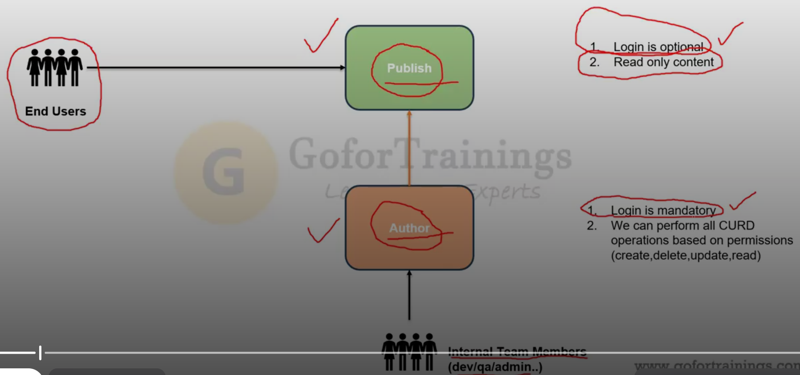

**Content - web pages, assets, cf,xf,tags**

1. Sites

2. Assets

3. Page Editor

4. package manager - Dev/QA/CA

localhost:4502/crx/packmgr

localhost:4502 -> start screen -> tools -> deployment -> packages

prod author - 100 pages

localhost:4502 - 10 pages

- content package

- download

localhost:4502

5. CRX De

- VS Code / IntelliJ / Eclipse

JCR - Java Content Repository

- unstructured/tree database

- nodes/properties

localhost:4502/crx/de

localhost:4502 -> tools -> general -> crx de

/

apps - components,clientlibs,osgiconfigs,18n

libs - components,clientlibs,osgiconfigs,18n

etc  - clientlibs,osgiconfigs,18n

content - web pages, assets, cf, xf, tags

conf    -  templates, content (text,asset references)

AEM 6.5 vs AEM Cloud:

---------------------

1. admin is not required in AEMAsc

1. remote server

2. java

3. author

4. publish

5. ssl/domain

6. apache web server

7. dispatcher

8. replication configuration

1. creation

2. maintenance

3. pipeline/git

4. Auto Scalability

AEM 6.5 Prod

1 - author

3 - publish -> 20K -> 50K

8 - publish -> 50k

Dev

- forms module

- Sling Repo Init

- SCD  - Cloud Services

AEM 6.5 jar   -

AEM Cloud SDK - localhost:4502 -> code -> test code -> push the code into GIT

  - Cloud Manager CI/CD pipelines -> remote servers (dev,qa,stage,prod)

Cloud Manager

- domains/SSL

- fastly CDN

AEM Cloud:

Dev

- author   - domain

- devauthor.destaco.com/crx/de - read only

- code - CI/CD Deployment

- content - CURD

- publish  - dev.destaco.com

QA

- author   - domain

- publish  - qa.destaco.com

Stage

- author   - domain

- publish  - uat.destaco.com

Prod

- author   - domain

- publish  - www.destaco.com

content sync

AEM As Cloud -  5L

AEM 6.5 + 19 -  1.7L

1+2 - admins

**Consoles:**

**In AEMACS:**

1. author & publish server installation

2. connect author with publish

3. install wknd sample project

1. UI/UX 🡪 html/css/js

2. AEM Dev - component (code html, css, js, java)

3. AEM QA - testing

4. AEM CA content creation

1. Sites - - pages

localhost:4502/sites

replicate, activate, publish 🡪 move the content from author to publish

2. Page Editor – CURD operation on page

3. Assets Console

4. Package Manager

**Local Project Setup: Google > search > Adobe AEM project archetype**

mvn -B org.apache.maven.plugins:maven-archetype-plugin:3.2.1:generate -D archetypeGroupId=com.adobe.aem -D archetypeArtifactId=aem-project-archetype -D archetypeVersion=48 -D appTitle="News Portal" -D appId="newsportal" -D groupId="com.bhasaka.newsportal"

**groupid should be > com.<companyname>.<projectname>**

**Recommended to run the above code in command prompt as a “Run as administrator”**

**Create a folder where you want this project setup and go to the folder and run the below code:**

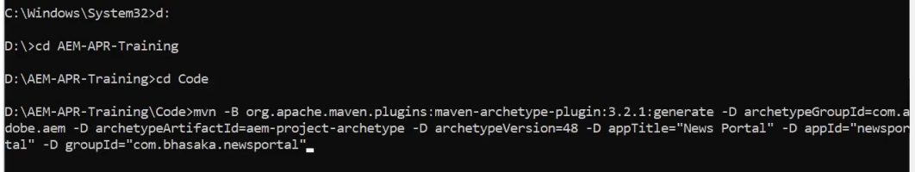

newsportal

frontend:   -> editors (VS Code/Eclipse/IntelliJ)

all

newsportal.all.<vid>.zip

newsportal.ui.apps.<vid>.zip

newsportal.ui.config.<vid>.zip

newsportal.ui.content.<vid>.zip

ui.apps

newsportal.ui.apps.<vid>.zip (Content Packages)

ui.config

newsportal.ui.config.<vid>.zip

ui.content

newsportal.ui.content.<vid>.zip

ui.frontend

localhost:4502/crx/packmgr

http://localhost:4502/crx/de

backend: -> editors (VS Code/Eclipse/IntelliJ)

core - 100 java files

newsportal.core.<vid>.jar  (Bundle)

localhost:4502/system/console

Go to the project folder and run the below command:

mvn clean install -🡪 To build a package to local root directory(content and core)

mvn clean install -PautoInstallPackage  (Frontend/Backend code)       -> localhost:4502

mvn clean install -PautoInstallPackagePublish  -> localhost:4503

mvn clean install -PautoInstallBundle (Backend code)         -> localhost:4502

login

- components,java -> localhost:4502

file system  -> push -> Remote GIT Repo -> CI/CD -> Remote AEM Servers (dev,qa,stage,prod)

**Use VS code for front end code writing/editing (**Add AEM sync plugin under extension to sync between local file system to local AEM server**)**

**IntelliJ for back-end code writing/editing** (sync code using command mvn clean install -PautoInstallBundle or mvn clean install -PautoInstallPackage)

**article-details.html**

<h1 class="title"> Jailer Movie Trailer </h1>

<img src="/content/dam/newsportal/images/jailer-trailer.png"/>

<div class="desc">Release date of Rajinikanth and Mohanlal starrer 'Jailer' is  2023-08-11.</div>

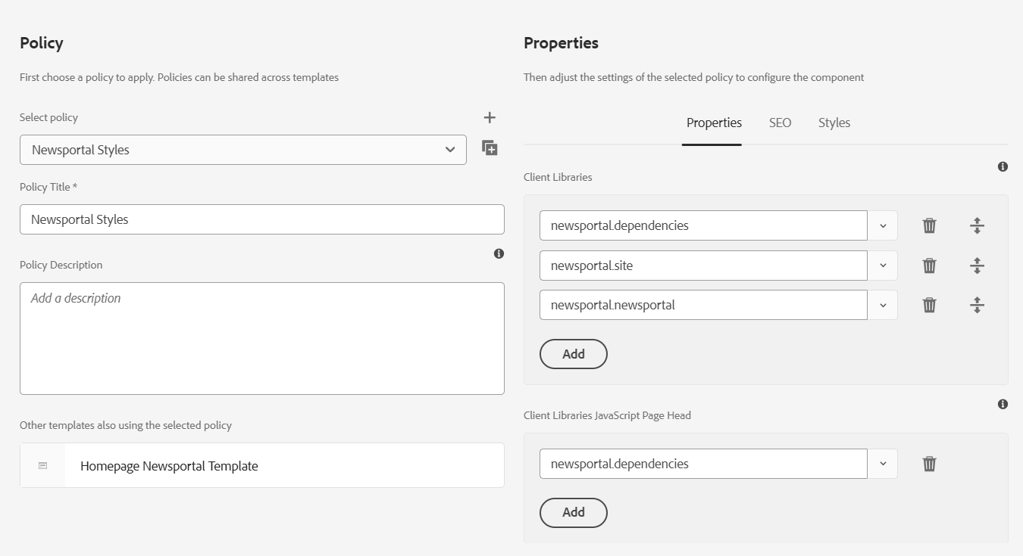

**Content:** text, asset/page reference

**Code :** <h1 class="title"> </h1>

1. Node type of component is **cq:Component**
2. /apps/<projectname>/components

**Node Names:**

article-details

article_details

articleDetails

Component Properties:

1. jcr:title
2. componentGroup

Component Child Node

cq:dialog

cq:editConfig

Allowed Component List  - template level configuration

**Components:**

JCR - Java Content Repository

- Storage (Database)

- unstructure/tree database 🡪 nodes and properties

localhost:4502/crx/de

code: apps (Custom component)

libs – Out of the box component

etc -

content:

custom code (components)

content -> web pages, assets, cf, xf, tags, forms

conf -> configuration & templates

var -> run time data

**article-details.html (HTML + HTL (Sightly))**

<h1> ${properties.articleTitle} </h1>

<div> ${properties. articleDesc} </div>

<img src="${properties.articleImage}" />

/apps/newsportal/components/article-details

sling: resourceSuperType 🡪 newsportal/components/helloworld

/apps/newsportal/components/helloworld

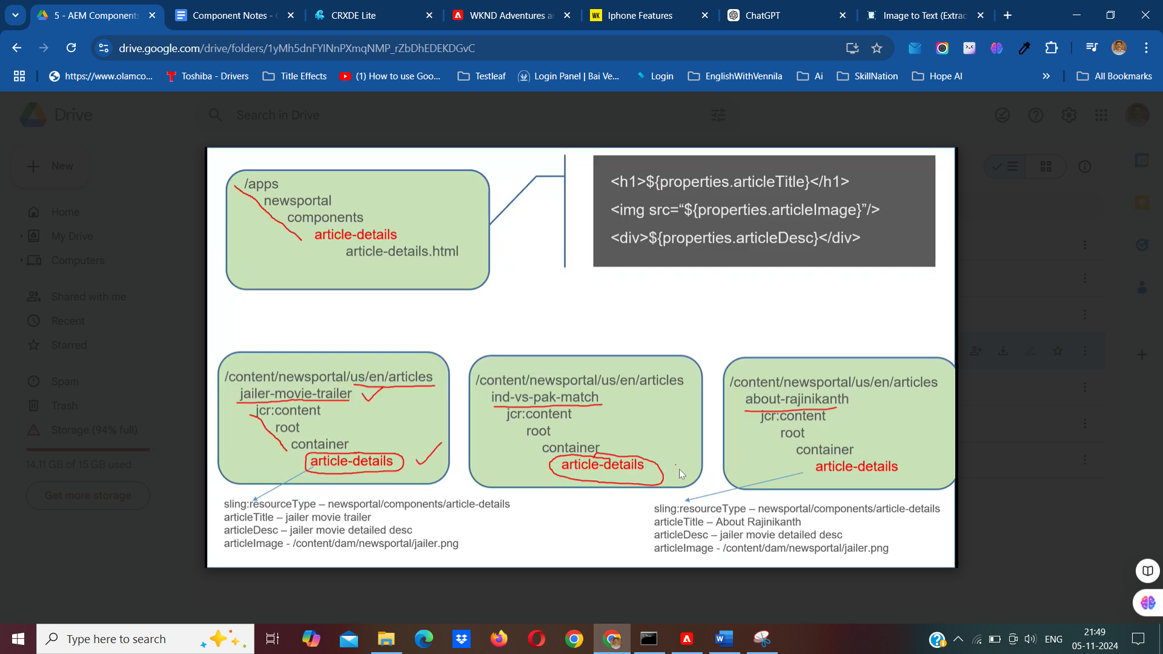

* **Sling creates content node in page level under container node when you drag and drop component on page.**
* **Content nodes store the actual content and properties associated with the components on the page.**
* **sling:resourceType property value in content node relative path of component.**
* **Dialog is Ul to edit/create/delete content node properties.**

**Touch UI Dialog & cq:editConfig:**

cq:editConfig > used to enable additional flexibility/features on the component dialog for authors. (inplaceEditor, dropTargets, listeners, formParameters, etc

**Granite UI - collection of components to build the dialog and it's fields**

ex: textfied

textarea

select

checkbox

pathfield

Coral UI

Normal Multifiled > article-label > field

**Composite mutifield:**

Article-label->composite – Boolean –true

<field> container

<items>

<title>

<path>

* **In the composite multifield, authored content on the dialog, always stored as child node of the actual content node.**

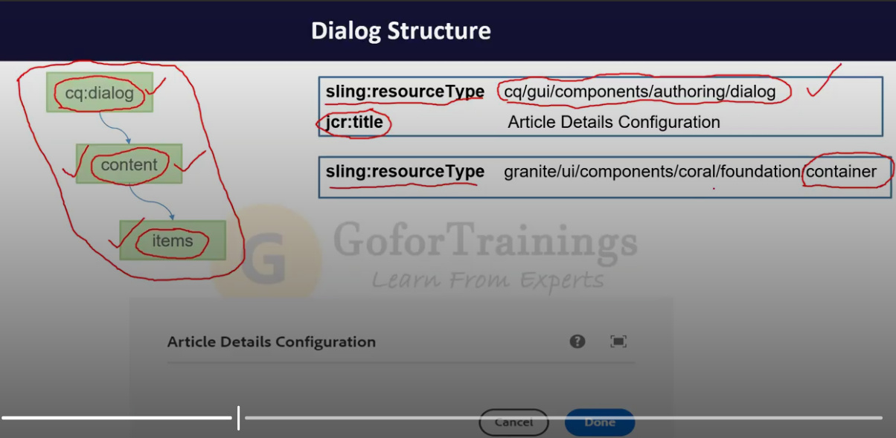

**Dynamic/Editable Templates:**

- N pages

Class:- Student

object

Student st1 = new Student (); Student st1 = new Student ();

1) Structure

define all the common components (ex: header and footer)

Article Template

20000 article pages

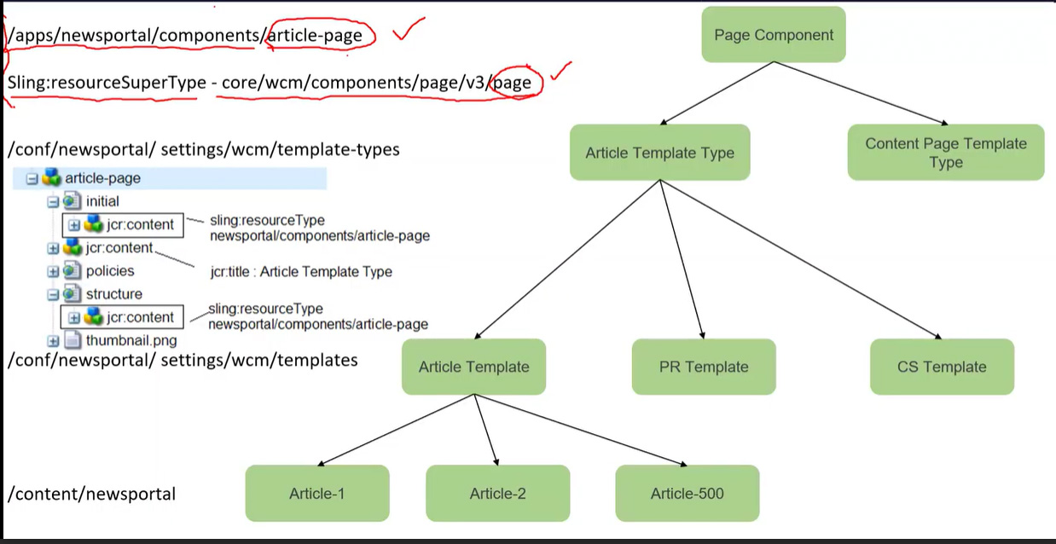

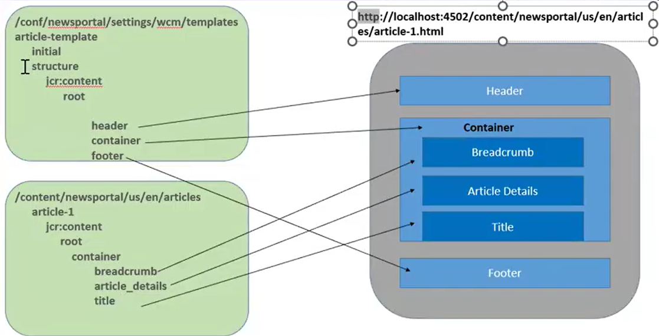

**Experience Fragment (XF):**

-------------------------

- small part of the web page

- cq:Page

- ex: header and footer

- define global/common content

/content

/experience-fragments

/newsportal

/us

/en

/site

/header (cq:Page)

master

jcr:content

root

top-bar

brand-logo

navigation

cs-header

jcr:content

root

top-bar

brand-logo

navigation

/footer

master

jcr:content

root

footer

footer-list-1

footer-list-2

footer-list-3

footer-list-4

footer-list-5

/conf

/newsportal

/settings

/wcm

/templates

/article-template

/structure

jcr:content

root

experience-fragment

fragmentContentPath : path of header master variation

/product-template

/structure

jcr:content

root

experience-fragment

fragmentContentPath : path of header master variation

/cs-template

/structure

jcr:content

root

experience-fragment

fragmentContentPath : path of header master variation

/newsportal

/us

/en

articles

article-1 (cq:Page)

jcr:content

root

container

experience-fragment

path - /content/experience-fragment/us/en/sites/header

   content page  -> editable template -> template type -> page component

   XF content

   -> XF Editable Tempalte : /conf/newsportal/settings/wcm/templates/xf-web-variation

   -> XF Template Type     : /conf/newsportal/settings/wcm/template-types/xf

   -> xfpage component     : /apps/newsportal/components/xfpage

2. article pages - 20000

ravi     - 5000

ramu     - 2500

ramya    - 7500

nishee   - 5000

article-1

writer-info

first name : ravi

last name  : kongari

email      : ravi.k@gmail.com

profile pic

/content/experience-fragment/us/en/sites/writer-info

master

- writre-profile

ramya

ramu

nishee

destaco.com/content/experience-fragments/newsportal/us/en/site/header/product-header.plain.html

**Content Fragments (CF):**

---------------------------------------------------

1. CF is an asset

2. /content/dam

3. Primary Type: dam:Asset

1. Headless Approach

2. Headfull Approach

3. Hybrid Approach (headless + headfull)

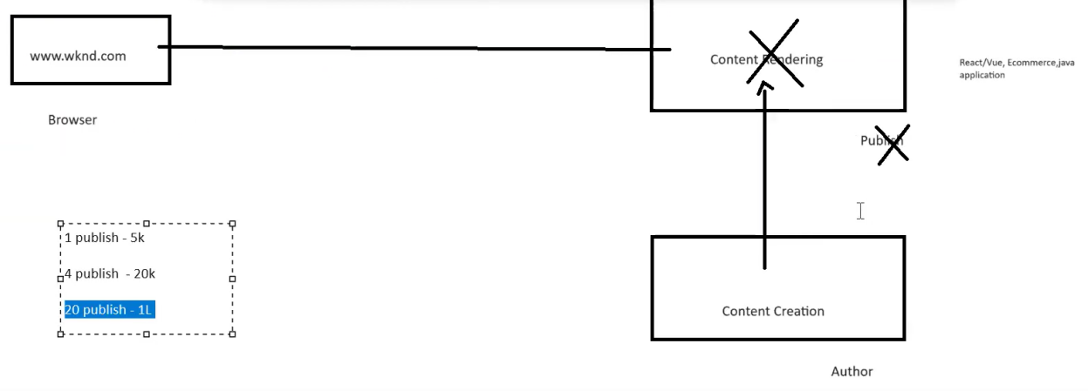

Archiving Headless, using below 2 implementations in AEM:

1. Asset HTTP API

localhost:4502/content/dam/newsportal/content-fragments/author-profiles

http://localhost:4502/api/assets/newsportal/content-fragments/author-profiles.json

2. GraphQL

Tools > General > GraphQL > Click on create and select newsportal.

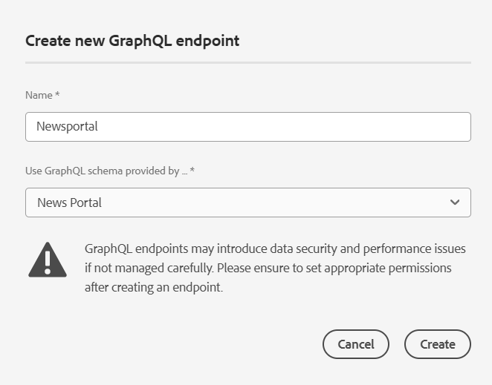

1. Editable Templates -> Web pages

2. CF Models (templates - dialog - (name,email,dob))  -> CF

/Content

1. web pages

2. assets

3. CF

4. XF

5. tags

6. forms

-------- CF Vs XF --------------------

1. We can use CF & XF for global content (common)

2. CF & XF are having variations

3. CF & XF support to export data (cf- .json, xf - .html)

**Difference:**

CF – Render plain content without design

XF – Render content with design (styles, ex: header,footer)

CF – headless approach

XF - personalization (target), marketing (mobile, email social,web) global content (ex: header and footer)

new-user

vip-user

activate-user

super-activate

product-a

mobile

email

social

web

12 fields - CF Model

v1 - 10

v2 - 11

0. type -> type1, type2

1. mobile

2. phone

3. email

http://localhost:4502/content/assets/newsportal/content-fragments/author-profiles.mobiledata.json

**HTL: (HTML Template Language) (Sightly is a OLD name)**

* Model View Controller (MVC pattern)

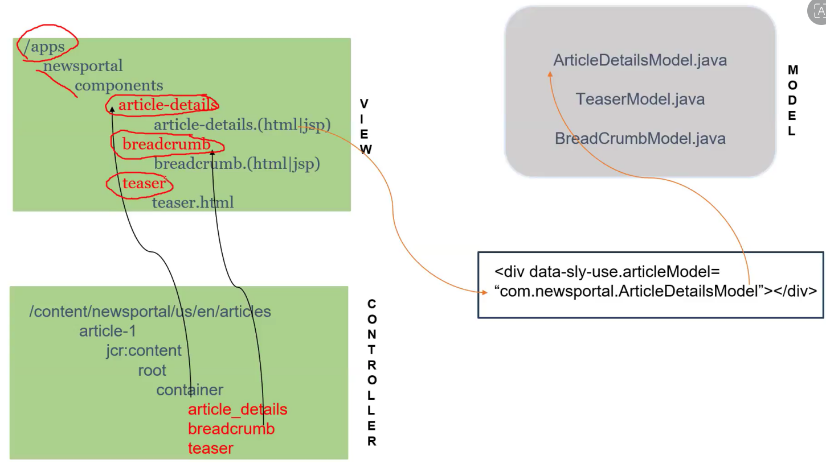

**HTL**

Advantages:

✓ Security

✓ Development efficiency

✓ Reduced Costs

✔Java knowledge is not required to write HTL

Expression:

The HTML Template Language uses an expression language to access the data structures that provide the dynamic elements of the HTML output. These expressions are delimited by characters **${ and }.** To avoid malformed HTML, expressions can only be used in attribute values, in element content, or in comments.

**<h1 class="${component.name}">${properties.jcr:title}</h1>**

**<h1 class="article-title" data-authorName="chamu"> AEM Cloud new fetures </h1>**

HTML Element- h1/sly

Attribute

* class/data-sly-test
* data-authorName

Text/Content -- AEM Cloud new fetures / ${}

**There are 13 HTL Custom Attributes/Block Statements: (First 8 are IMPORTANT out of 13)**

1) **data-sly-use** 🡪 create object for java, js, html and content nodes

Student st = new Student ();

**article-details**

article-details.html (html + htl)

<div data-sly-use.st="Student"> </div>

OR

<div data-sly-use.st=”com.bhasaka.newsportal.model.Student”></div>

2) **data-sly-include 🡪** to **i**nclude one html file into another html file

**article-banner**

writer-info.html

**article-details**

article-details.html 50 lines

<div data-sly-include="newsportal/components/article-banner/writer-info.html"></div>

<div data-sly-include="article-tags.html"></div>

writer-info.html - 25 lines html

article-tags.html

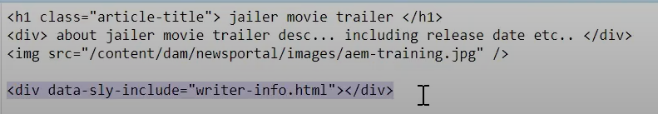

3) **data-sly-resource** 🡪 to include one component into another component

**article-details**

article-details.html

<div data-sly-resource="${'np-button' @resourceType @resourceType ='newsportal/components/button' }"></div>



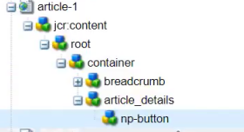

**4) data-sly-test** 🡪 Similar to if condition. **************************

If the title is available, then only the inside code will be executed. If the title is BLANK or NULL, the inside code will not be executed.

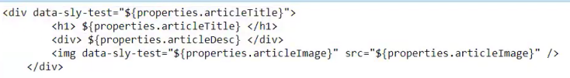

5) **data-sly-list** 🡪 Iterate list of objects (eg. Array, Any collection object (ArrayList, HashSet, HashMap))*****************************************

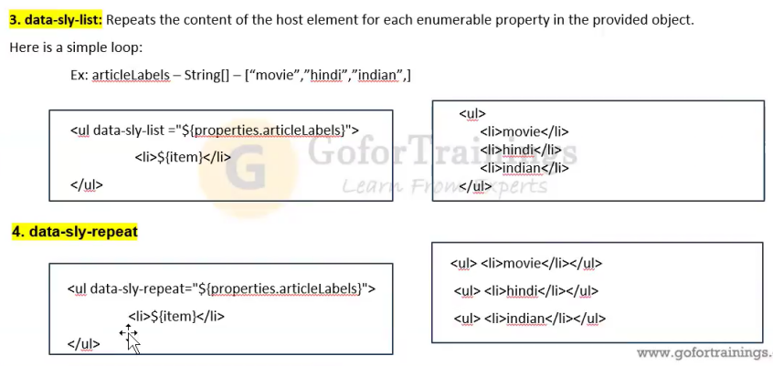

* **If we not mentioned the variable, It takes variable name as “item” by default.**

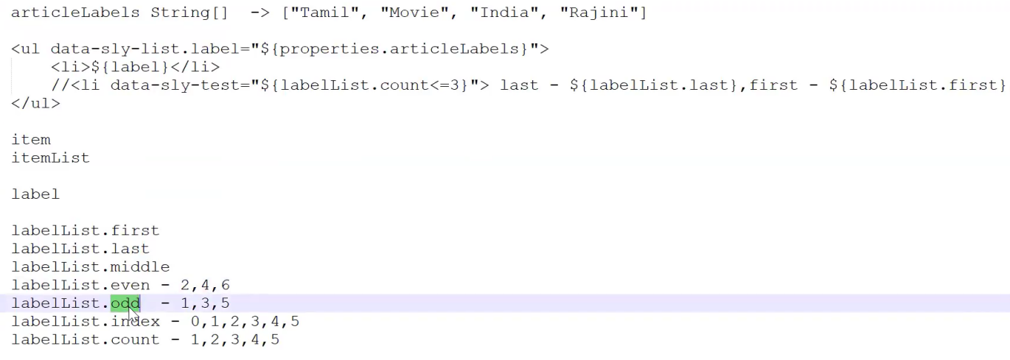

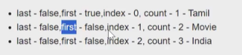

6) **data-sly-repeat** 🡪 It will repeat the host element and child element***********************



**7) data-sly-template** 🡪 It is used to define the block of reusable content. Similar to function/method. Reuse the block wherever needed. **************************

1. Define the template without passing the arguments. It’s recommended.

<div data-sly-template.myCode>

<h1>title</h1>

<p>description</p>

</div>

2. Define the template with passing the arguments. Arguments begin with **@.**

<div data-sly-template.myCode=”${@fName, lName, eMail }”>

<p>Firstname: ${fName}</p>

<p>Lastname: ${lName}</p>

<p>Email: ${eMail}</p>

</div>

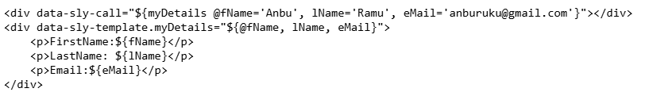

**For Dynamic:**

data-sly-call=”${writerInfo @fName=properties.firstName,@lName=properties.lastName}”

**IF THE TEMPLATE CODE/BLOCK IN DIFFERENT HTML FILE, WE HAVE TO CREATE AN OBJECT TO CALL THE TEMPLATE CODE/BLOCK.**

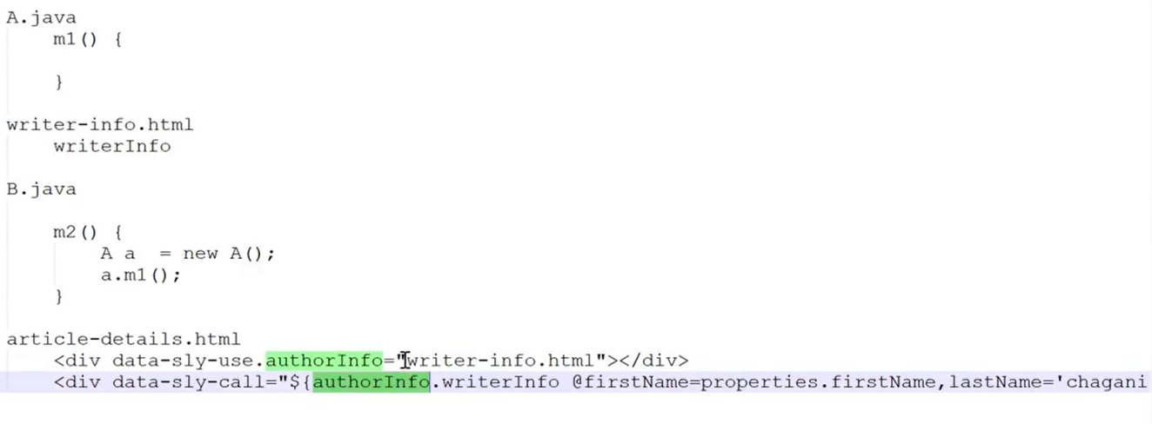

**8) data-sly-call** 🡪 Used to call a defined template code/block **************************

<div data-sly-call=”${Name}”></div>

<div data-sly-call="${myDetails @fName='Anbu', lName='Ramu', eMail='anburuku@gmail.com'}"></div>

<div data-sly-template.myDetails="${@fName, lName, eMail}">

<p>FirstName:${fName}</p>

<p>LastName: ${lName}</p>

<p>Email:${eMail}</p>

</div>

**We can add clientlibs in 2 ways:**

1. Template policy
2. HTL

HTL

/libs/core/wcm/components/commons/v1/templates/clientlib.html

Templates:

js

CSS

all

<div data-sly-use.clientlib="core/wcm/components/commons/v1/templates/clientlib.html"></div>

<div data-sly-call="${clientlib.js @categories='newsportal.desktop'}"></div>

clientlib-desktop.js

<div data-sly-call="${clientlib.css @categories='newsportal.desktop'}"></div>

clientlib-desktop.css

<div data-sly-call="${clientlib.all @categories='newsportal.desktop'}"></div>

clientlib-desktop.css

clientlib-desktop.js

**9.data-sly-element:** Replaces the element name of the host element. Ie. replace the html element in dynamically from the content node value.

<h1 data-sly-element="${properties.titleType}">${properties.articleTitle}</h1>

**10. data-sly-text:** Replaces the content of its host element with the specified text.

Ex: <p data-sly-text="${properties.jcr:description}">Lorem ipsum</p>

**Both are same:**



**11. data-sly-attribute:** Adds attributes to the host element.

Ex: <div title="Lorem Ipsum" data-sly-attribute.title="${properties.jcr:title}"></div>



**12. data-sly-unwrap:** removes html element from rendering 🡪 Instead of this we use <sly>

<p data-sly-use.nav="navigation.js">Hello World</p>

**13. data-sly-set:** define variable and assign values

<sly data-sly-set.title="${properties.articleTitle}" />

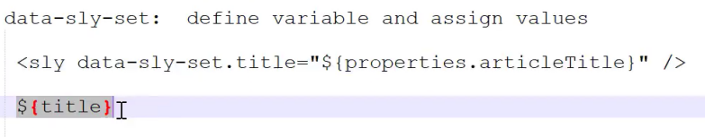

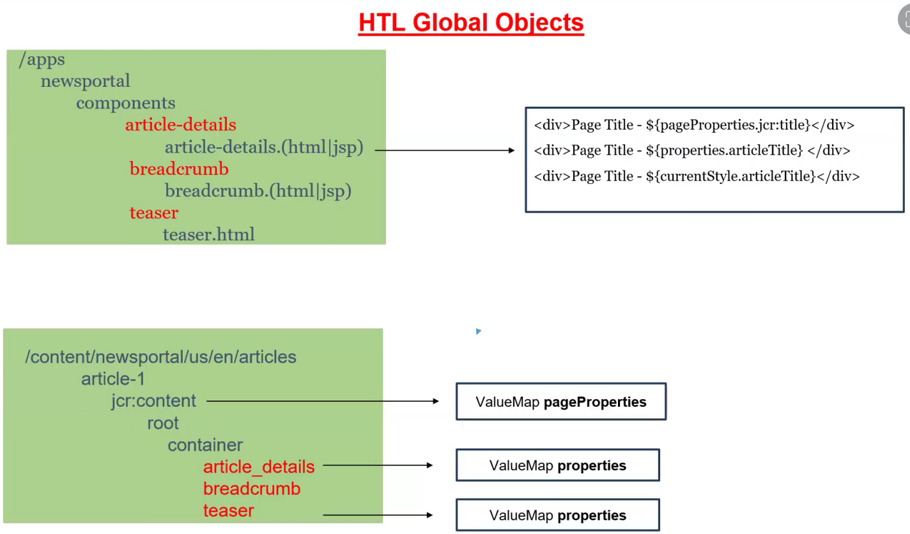

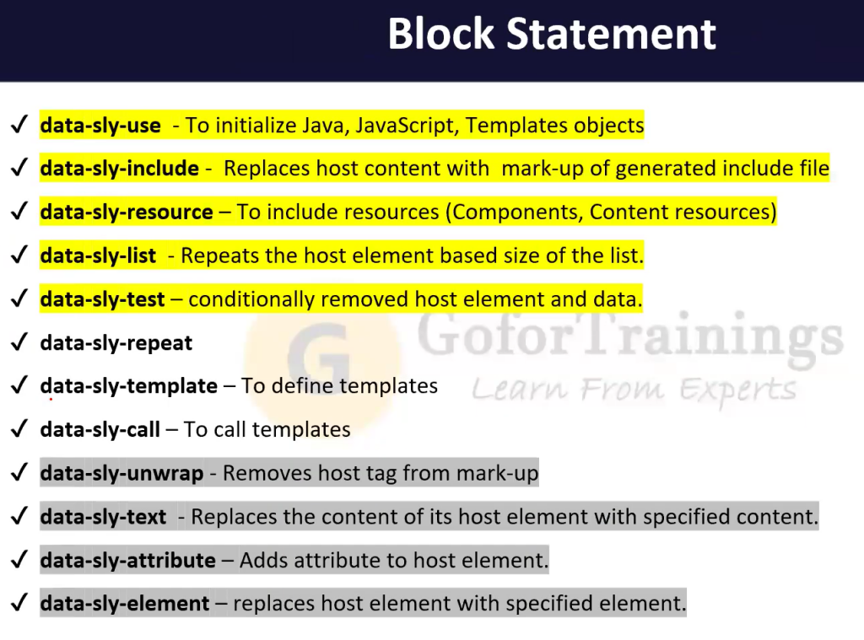

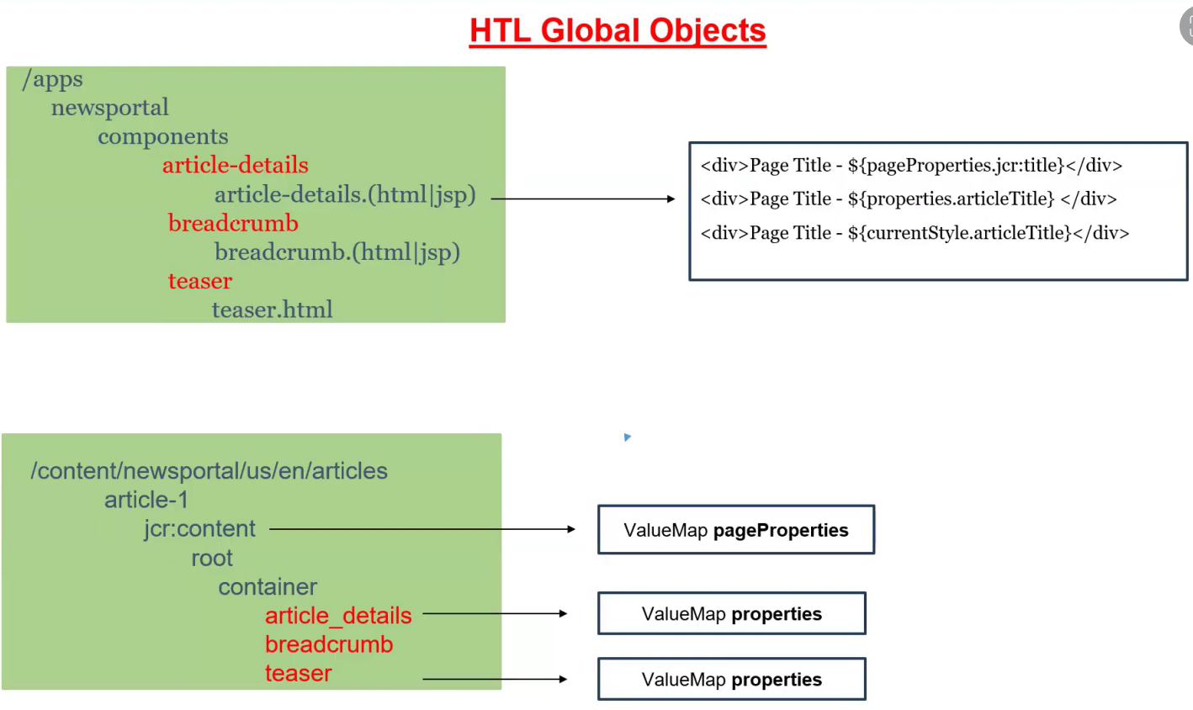

**HTL Context: (By default is @context=’text’)**

<h1> ${properties. articleTitle @context='html'} </h1>

jailer <b>movie</b> trailer

<a href="${properites. article Page @context='href'}"> ${properties.articleTitle @context='text'} </h1>

JS/CSS - context is mandatory

<script>

var articleTitle = ${properties.articleTitle @context='scriptString'};

var ${properties.variableName @context='scriptToken'} =’test’;

</script>

<style>

.article-titl {

content: ${properties.articleTitle @context='styleString'}

${properties.type @context='styleToken'}:'red'

</style>

1. JCR - Java Content Repository (Specification)

- Apache Jackrabbit is an implementation

2. Apache Sling - Request Processing

3. OSGI - Java Framework

- Specification

- Apache Felix is an implementation (Apache is a company, Felix is a project)

A 1.0.jar

A 2.0.jar

B.1.0.jar

A.1.0.jar

C.1.0.jar

A.2.0.jar

----------------------------------------------------------------------------------------------------------------

newsportal

core (100 java) -> newsportal.core.<VID>.jar (9.15 AM)

-> newsportal.core.<VID>.jar (9.30 AM)

jar file contains the below 3 things:

1. compiled java class (.class)

2. manifest.mf (metadata information)

3. resources (xml, json, small icon images, properties)

> mvn clean install 🡪 It will create a jar inside a target folder. If already jar file available on the target folder, new jar will be replaced.

**> mvn clean install -PautoInstallBundle > Move it localhost:4502**

**BundleActivator -> OSGI Interface**

**BundleActivatorImpl implement BundleActivator**

**1) start**

**2) stop**

**manifest.mf**

**Export-Package**

**Import-Package**

**Bundle-Activator**

**Private-Package**

**core.jar**

com.bhasaka.newsportal.core.services. Product InfoImpl.java

**Import-Package** com.bhasaka.newsportal.payment.services (Call the allowed package)

**payment.jar**

com.bhasaka.newsportal.payment.services. PaymentServiceImpl.java

**Export-Package** com.bhasaka.newsportal.payment.services (It allow to use the package to other.)

**Private-Package** : com.bhasaka.newsportal.payment.history (It will not allow to use/import other)

Difference between jar and bundle:

* Both are having .jar extension
* Bundle contains additional metadata headers eg. Export-Package, Import-Package, Private-Package.

**OSGI Components & Services:**

----------------------------------------------------------------------

**OSGI Component:**

- It is a Java Class and has additional ability to listen lifecycle events such as @Activate, @Deactivate & @Modified

- OSGI Component can listen lifecycle events (activate, deactivate, modified)

**OSGI Annotations:**

-----------------

**Class Level:**

1. @Component  🡪 It will register a normal java class into OSGi component.

**Method Level:**

2) @Activate

3) @Deactivate

4) @Modified

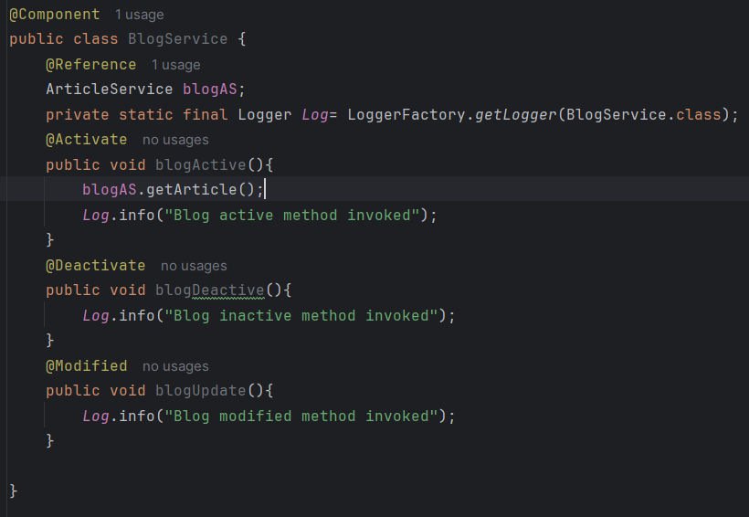

5) @Reference – We call one component into another

@Reference will assign a dynamic object that is created by osgi container to

ArticleService articleObj;

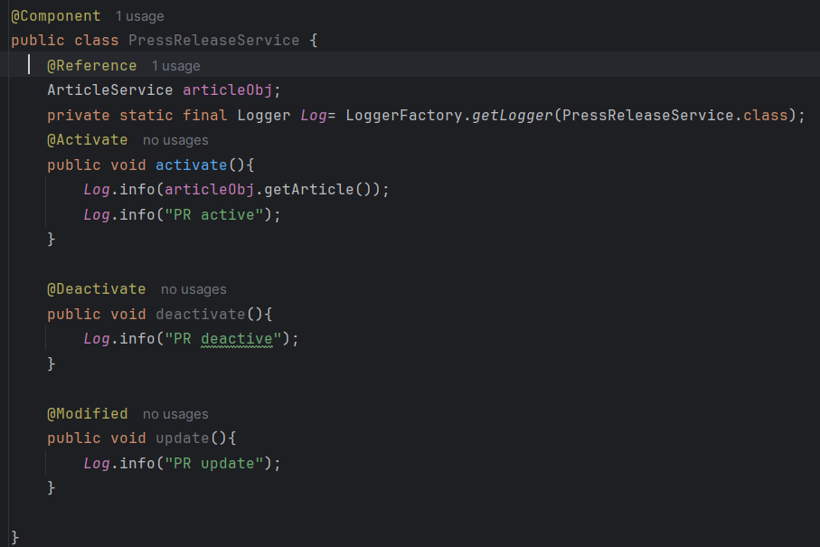

If you want to use once OSGi component into another OSGi component, we have to convert that component into OSGi service component.

Eg.

@Component(service=ArticleService.class)

We can’t define OSGI service, without OSGI component.

OSGi service is an OSGi component. But OSGi component may or may not be an OSGi service.

ArticleService

@Activate

- activate()

@Deactivate

- deactivate()

@Modified

- update()

PressReleaseService

- activate

- deactivate

- update

newsportal.core.vid.jar

- activate

- Container Identify all OSGI Component java classes based on XML files inside jar file

- Register OSGI component java classes with OSGI container

- Creates Object for all OSGI Component Java classes

- Triggers activate event and execute activate method.

**IMPORTANT:**

1. All OSGI components are singleton () java classes.

2. We can't create object for OSGI components.

Browser - Client

  Request - <https://gorest.co.in/public/v2/posts>

Java

- Client

- Request

- Response

- convert response into string

**OSGi Dynamic Configuration:**

OSGi annotation:

**Class level:**

@Designate > Link the configuration class file with osgi component “ArticleService.class” file

@ObjectClassDefinition > used to create a dynamic osgi configuration class

**Property level:**

@AttributeDefinition

**Step 1:** Create a configuration class and define 3 properties that are make it dynamic.

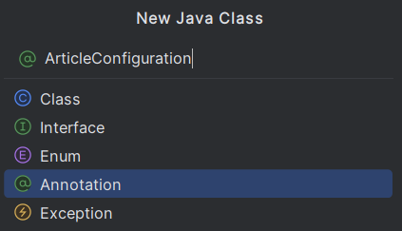

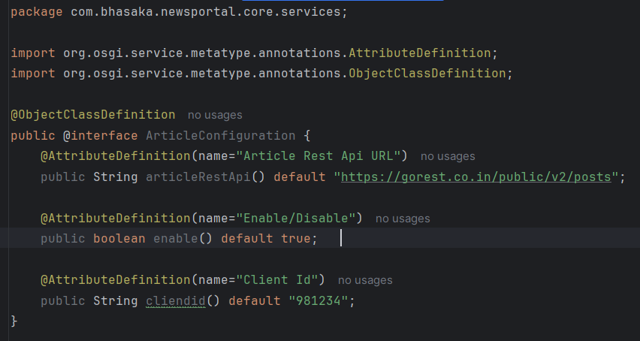

Step 2: Link the configuration class file with osgi ArticleService.class file using @Designate

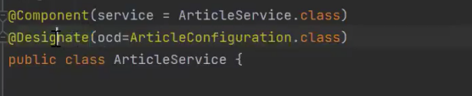

Step 3: We have to pass the dynamic configuration class as an argument to all lifecycle method (Activate, Deactivate, Modified)

Using the dynamic object **config**, call the method from ArticleConfiguration class. And assign it to instance variable.

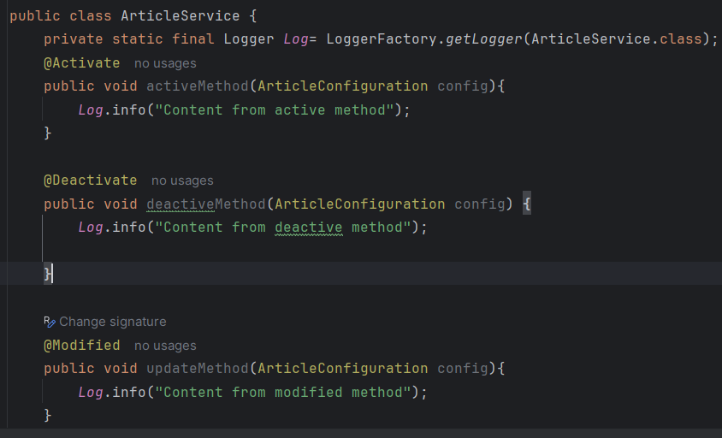

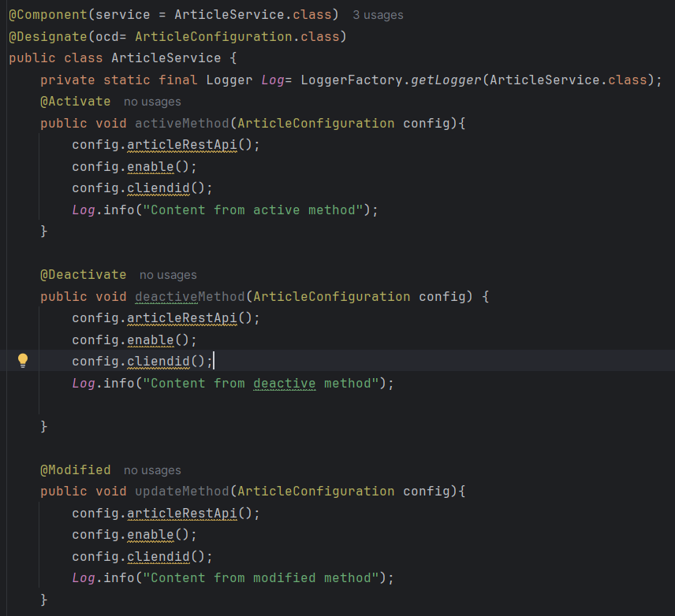

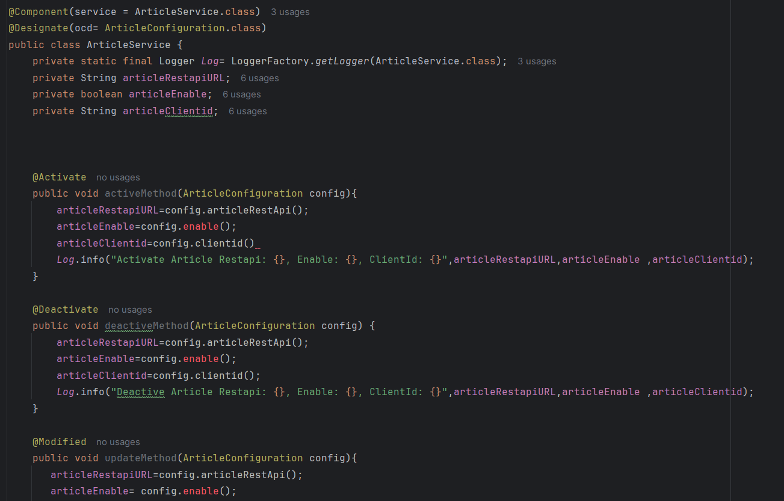

Step 4: We have to create a dynamic configuration file (JSON) under ui.config module.

ui.config

/apps

/newsportal

/osgiconfig

/config

com.bhasaka.newsportal.core.services.ArticleService.cfg.json (//cfg is a selector and json is an extension)

{ // These key : value pair taken from ArticleConfiguration.class file. Key is a dynamic property, go configuration class file take it from there. Value we can define.

“articleRestApi”:”https://www.google.com”,

“enable”: “true”,

“clientid”:”989898”

}

Terminal:

>cd ui.config

ui.config> cd mvn clean install -PautoInstallPackage

cd ../core

core> mvn clean install -PautoInstallBundle

Update Dynamic Configuratin:

----------------------------

1. CRX De

2. System Console Configuration

ui.config

/apps

/newsportal

/osgicongis

/config

com.bhasaka.newsportal.core.services.ArticleService.cfg.json

{

"articleRestAPI":"https://gorest.co.in/public/v2/posts",

"enable":"true",

"clientId":"8908978"

}

Runmodes:

---------

Standard/Installation/OOTB/Primary Runmodes:

--------------------------------------------

1. author

2. publish

3. samplecontent    - we-retail

4. nosamplecontent

aem-author-p4502.jar

java -jar aem-author-p4502.jar -gui -r nosamplecontent

author,samplecontent

author,nosamplecontent

publish,samplecontent

publish,nosamplecontent

Custom/Secondary Runmodes:

--------------------------

AEM 6.5:

--------

ex: dev,qa,stage,uat,prelive,live,prod,sit ....

AEM Cloud:

----------

dev,stage,prod,rde

1. To identify the server

2. To select runmode specific configuration.

1. java -jar aem-author-p4502.jar -Dsling.run.modes=dev

2. author

crx-quickstart

conf

  sling.properties (file)

sling.run.modes=qa

3. java -jar aem-author-p4502.jar -r prod

*****************************************************************************************

**Sling Model**

*****************************************************************************************

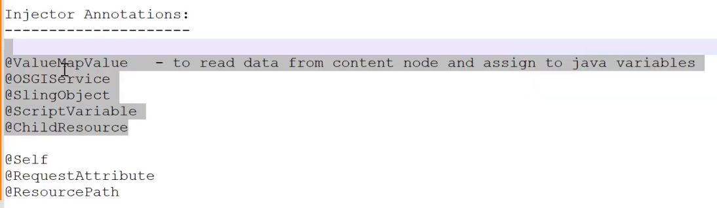

1. @Model

resourceType =”/newsportal/component/article-details”// Component path

2. @PostConstruct

3. **@Exporter > used to export data in the form of json (Headless & Hybrid approach)**

name and extensions attributes are required.

name > convert the java object into JSON using Jackson library

extensions > json

Instead of the using hard coder value use exporter constant value (ie. Jackson)

resourceType attribute should be added under @Model

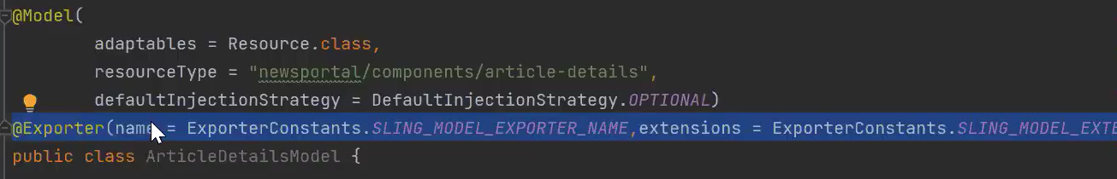

4. @Default

5. @Optional

6. @Required

7. @Named

8. @Inject > NOT in USE and NOT Recommended, Generic annotation to inject all type of data(content node properties, osgi services, global objects)

> It will identify the best suitable injector and executing injector. So, I will impact performance. But when we use @ValueMapValue, It will directly execute the injector without searching.

@Inject

private String articleTitle;

OR

@Inject

@Source(“valuemap”)

private String articleTitle;

@Inject

private ArticleService articleService;

@Inject

Private ResourceResolver resolver;

9. @Via > It will read content node, OLD ONE

@ValueMapValue(via="request")  // It will read the data from the request object. default source - resource (content node)

// @Via("request") > OLD

private String articleTitle;

10. @Source

@Inject

@Source("valuemap")

private String articleTitle;

@Inject

@Source("osgi-services")

private ArticleService articleService;

**Injector: (Out of 8 injector, 5 is IMPORTANT)**

1. @ValueMapValue // **Injector Annotations, To read data from the content node and assign it to java variable.**

**Name attribute is used map the node property with java variable.**

@ValueMapValue(name ="sling:resourceType")

@Default=”/content/newsportal/pages/”; **// Assign a default value if no content on the field instead of showing default value NULL/0/etc…**

@Named (older implementation)

@Optional (older implementation)

@Required (older implementation)

private String slingResourceType;

2. @OSGIService  // @Referece -> inject OSGI services into sling model

HTL Global Object // convert htl global object into Sling model

> 28 global objects are available and divided into two parts/categories:

@Sling Object & @ScriptVariable (i.eNon Sling Object)

3. @SlingObject

The 2 things are IMPORTANT while injecting data into sling model.

Eg. @SlingObject

**ResourceResolver resolver**; // The variable name resolver should match with the global object name.

Include: under @Model

(adaptables={**SlingHttpServletRequest**.class}

**OBJECT** **CLASS**

request org.apache.sling.api.SlingHttpServletRequest

resolver org.apache.sling.api.resource.ResourceResolver

resource org.apache.sling.api.resource.Resource

response org.apache.sling.api.SlingHttpServletResponse

sling org.apache.sling.api.scripting.SlingScriptHelper

4. @ScriptVariable

component com.day.cq.wcm.api.components.Component

componentContext com.day.cq.wcm.api.components.ComponentContext

currentContentPolicy com.day.cq.wcm.api.policies.ContentPolicy

currentContentPolicyProperties= com.day.cq.wcm.api.policies.ContentPolicy

currentDesign com.day.cq.wcm.api.designer.Design

currentNode javax.jcr.Node

currentPage com.day.cq.wcm.api.Page

currentSession javax.servlet.http.HttpSession

currentStyle com.day.cq.wcm.api.designer.Style

designer com.day.cq.wcm.api.designer.Designer

editContext com.day.cq.wcm.api.components.EditContext

log org.slf4j.Logger

out java.io.PrintWriter

pageManager com.day.cq.wcm.api.PageManager

reader java.io.BufferedReader

slyWcmHelper com.adobe.cq.sightly.WCMScriptHelper

wcmmode com.adobe.cq.sightly.SightlyWCMMode

xssAPI com.adobe.granite.xss.XSSAPI

resourceDesign com.day.cq.wcm.api.designer.Design

resourcePage com.day.cq.wcm.api.Page

5. @ChildResource – **It will be useful to read composite multifield data**

@ChildResource

List<RelatedArticleItemModel> relatedArticles;

<ul data-sly-list.relatedArticle="${articleModel.relatedArticles}">

<li><a href="${relatedArticle.articlePath @extension='html'}">${relatedArticle.articleTitle}</a></li>

</ul>

article-1

jcr:content

root

container

artilce-details

relatedArticles

item0

- articleTitle

- articlePath

item1

item2

item3

6. @Self -> inject one sling model into another sling model.

7. @ResourcePath > Create a object for the content node repository NOT IMPORTANT, will converted in API session.

Eg. > based on the path, create a object

@ResourcePath(path=”/content/newsportal/us/en/jcr:content”)

Resource contentResource;

8. @RequestAttribute > to pass additional data in htl and read in sling model using this attribute.

  private String type;

eg.

<sly data-sly-use.articleModel="${'com.gofortrainings.newsportal.core.models.ArticleDetailsModel' @type='sports'}" />

article-details

<sly data-sly-use.articleModel="${'com.gofortrainings.newsportal.core.models.ArticleDetailsModel' @type='article-details'}" />

article-banner

<sly data-sly-use.articleModel="${'com.gofortrainings.newsportal.core.models.ArticleDetailsModel' @type='article-banner'}" />

*****************************************************************************************

**Sling Servlet:**

*****************************************************************************************

* It is a OSGi service. We can access this from the browser.
* It’s Rest API.

Eg.

We have created OSGi service ie. “ArticleService” under core> module>services (*We can’t access this through browser directly*)

1. Using Sling Model, we can access the OSGi service OR
2. Access this in another OSGi service using @Reference OR
3. We call this service directly in the HTL (component.html) using object.

**HTTP Request method types:**

1. **GET** > Default > Read > perform read operation to fetch data from server.

2. **POST** > Create > perform write operation to post data from client to server. Eg. Contact Form data. When we entering the firstname, lastname in the contact form, It will go from client to server.

3. **PUT** > Create/Update > To create a new data/updating existing data. Eg. Contact address in Amazon online purchase.

4, **DELETE** > Delete > delete the data from the server.

Client (browser/postman) > Server (AEM)

**RecentArticleServlet extends SlingAllMethodServlet/SlingSafeMethodServlet**

RecentArticleServlet is an Implementation class

**SlingSafeMethodServlet**

* Read - GET

**SlingAllMethodServlet**

* Read – GET
* Write - POST, PUT, DELETE

🡪Every servlet is an OSGi Service. In order to register it as a service, It must be a @Component.

Service class should be attribute of the @Component

Eg.

**@Component(service=Servlet.class) // Servlet is an interface**

**public class RecentArticleServlet extends SlingSafeMethodServlet{ //** SlingSafeMethodServlet supports GET,POST, PUT, DELETE

**}**

**Two types of Servlet:**

**1.Path Based Servlet**

**@SlingServletPaths**(“/bin/newsportal/recent-articles”) // **Based on the URL only browser identify the servlet.**

**It’s a virtual object and not physically present in the JCR repository.**

client (browser)

localhost:4502/bin/newsportal/recent-articles

**HTTP Request Method**

―---------------------------------

GET

POST

PUT

DELETE

--------------------------------------―

**RecentArticleServlet**

doGet

do Post

do Put

doDelete

**Disadvantage:**

1. paths are hardcoded in java codes.

2. can't apply permissions.

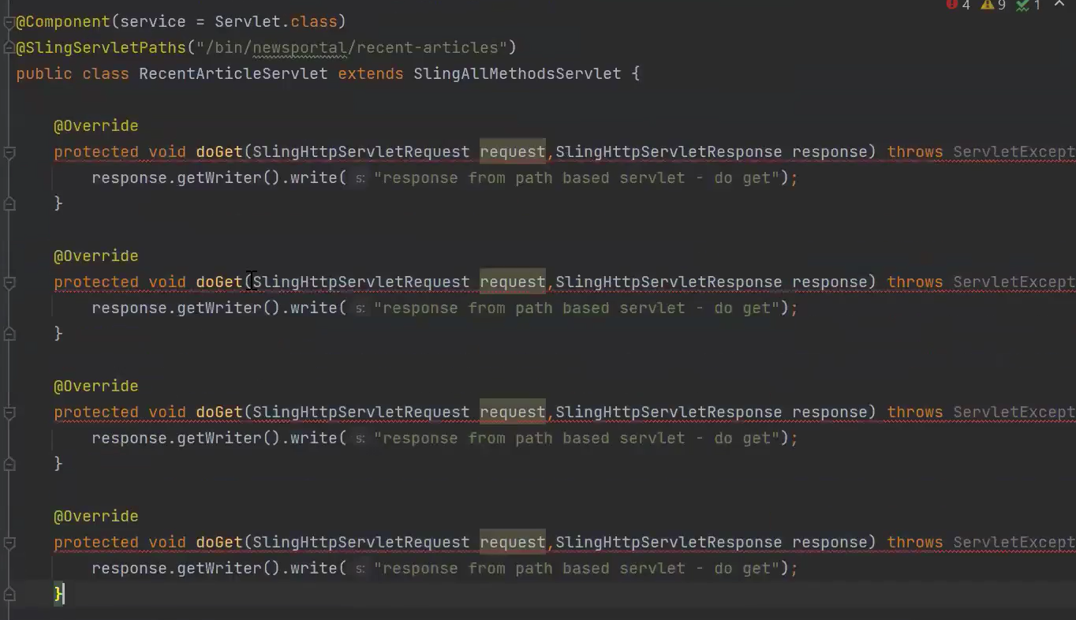

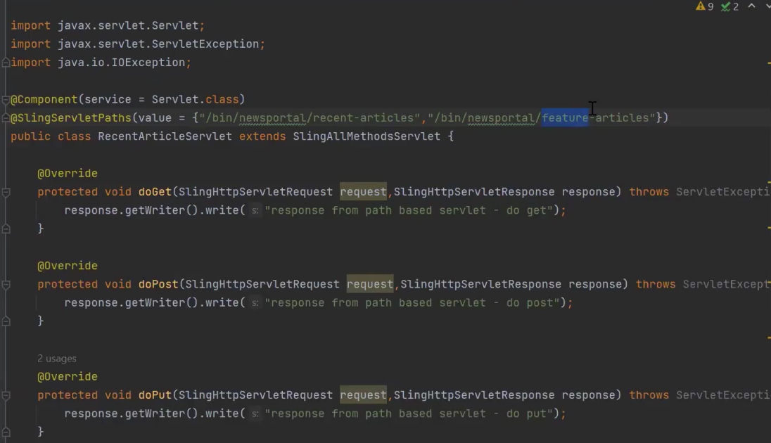

Terminal:

> cd core

core>mvn clean install -PautoInstallBundle

Go to browser > [http://localhost:4502//bin/newsportal/newsarticle //](http://localhost:4502//bin/newsportal/newsarticle%20//) doGet will executed

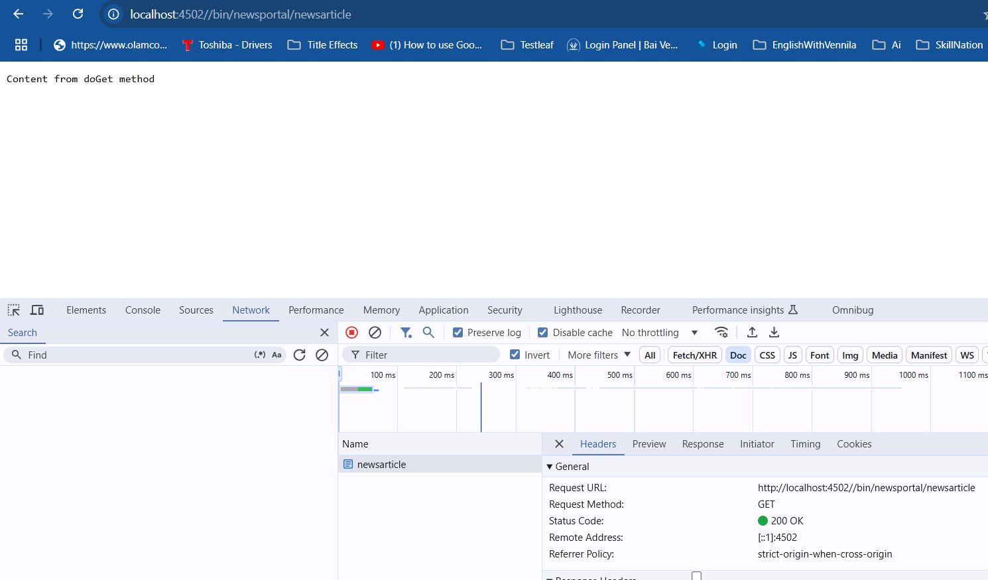

We can test doPost, doPut, doDelete in 2 ways:

1. Via javascript Ajax call
2. HTTP client > such as Postman

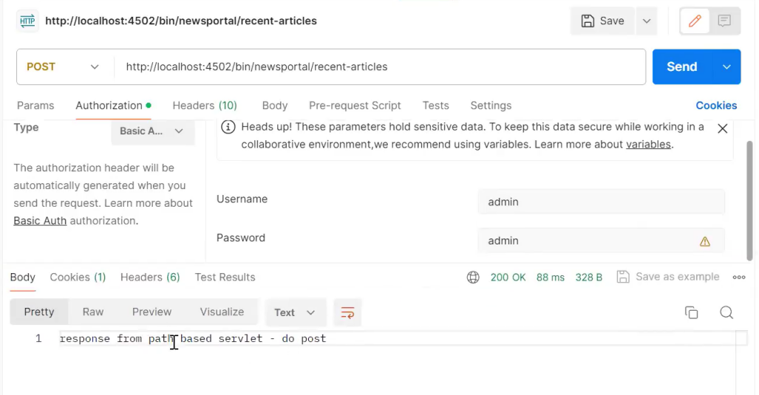

If we want to use our own servlet path instead of this **> /bin/newsportal/recent-articles** (this is an identifier in the servlet configuration and used to identify the servlet. And we have to allow this URL in the dispatcher filter section.)

Go to > <http://localhost:4502/system/console/configMgr>

Search term :” ServletResolver”

**Click on it:**



**Click on + icon and add “/newsportal/” and click SAVE.**

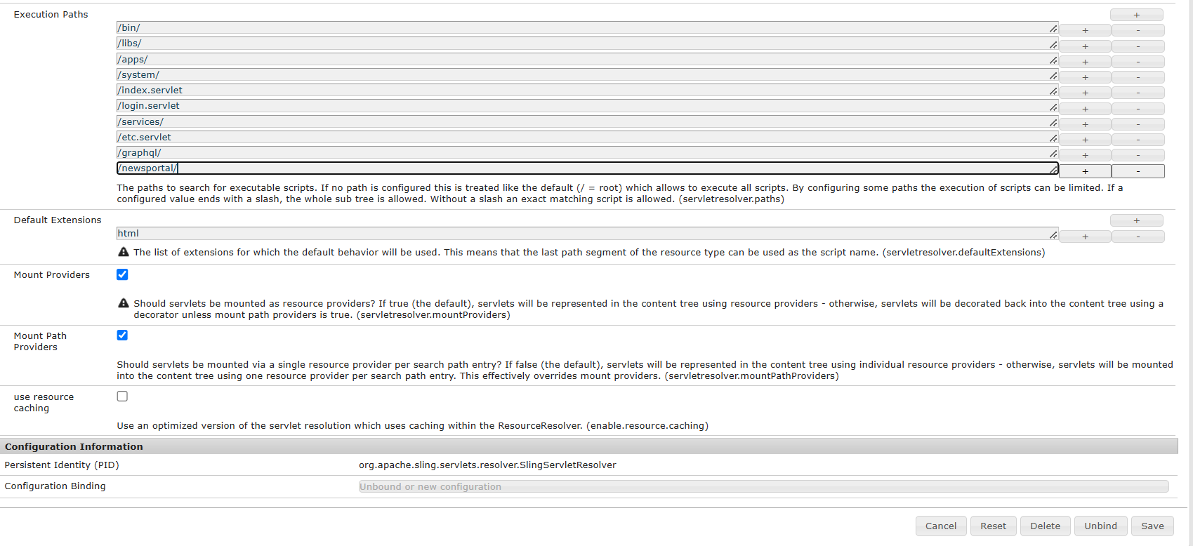

Go to servlet file and remove bin and update path.

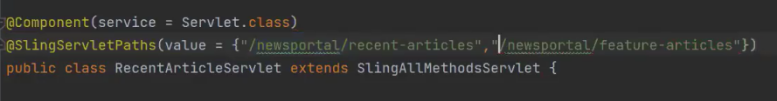

**2. Resource Based Servlet:**

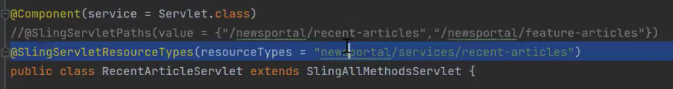

**We can’t access “Resource Based Servlet” using the above URL. Because, resource means node. Through node only we can access the “Resource Based Servlet”**

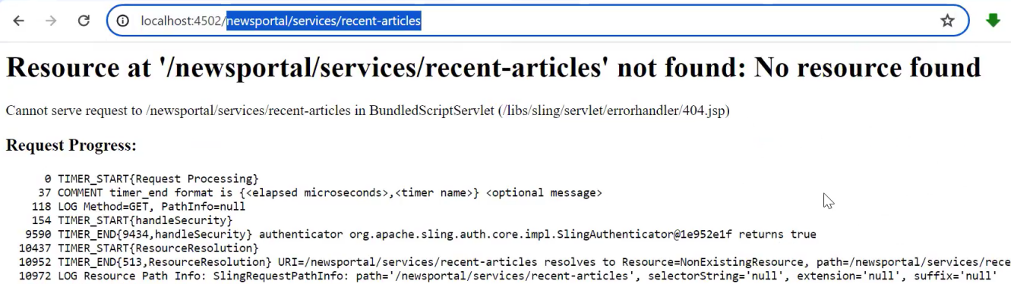

**Go to crx/de > We have to create a node under content and add sling:resourceType and mention the resourceTypes URL given on the servlet class.**

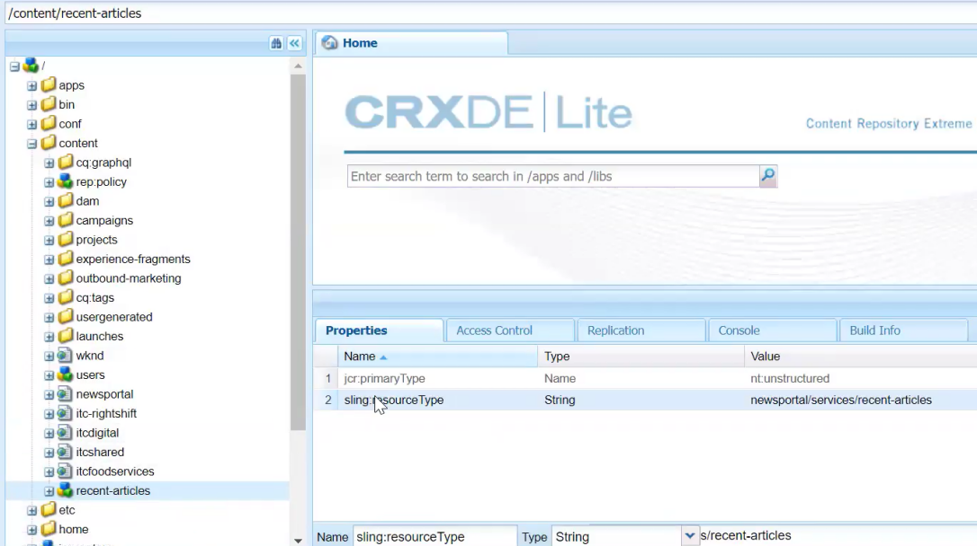

Now, we can access the servlet using the content node path.

<http://localhost:4502/content/newsarticle/>

* It physically exists
* Able to give permission

Using the node path only, we are accessing the servlet. So, we can create many nodes with different names to access the servlet.



Also, we can mention the extensions, allowed methods and selectors.

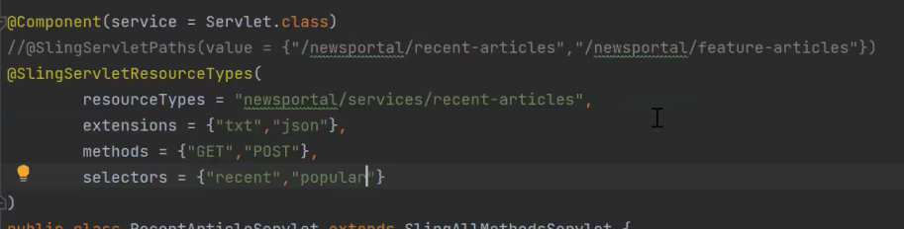

Selectors > It is a part of the URL and It is available in between the content node path and extensions.

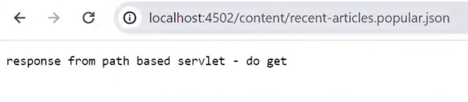

If you want to know the class implementation of the servlet, there is one more console,

* System/console > Sling > Sling Servlet Resolver

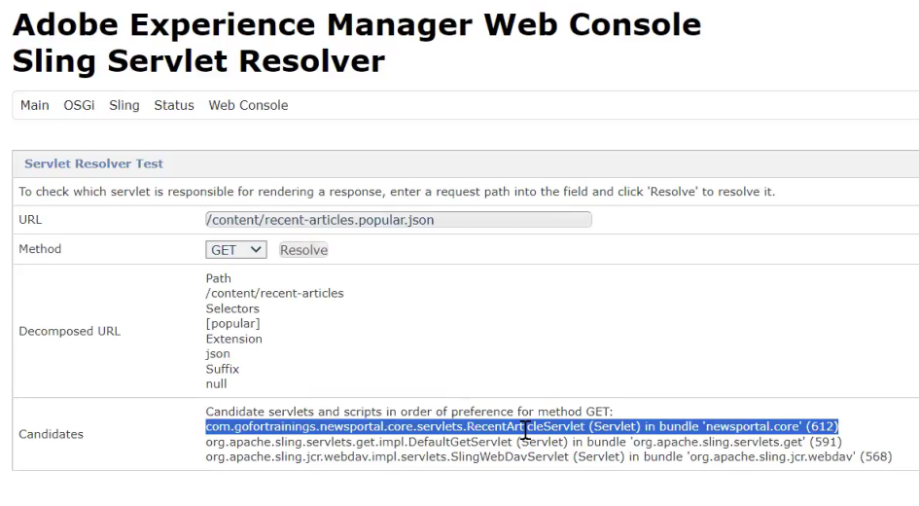

If we have more than servlet, have a create a new node and add sling:resourceType. Each node will pointing to one servlet or component.

*****************************************************************************************

**Sling API**

*****************************************************************************************

**Sling API:**

(CUED create, update, read, delete)

1. ResourceResolver

1. request.getResourceResolver();

2. System/Service User

2. Resource

-> /content

/users

ResourceResolver resolver = request.getResourceResolver ();

Resource userResource = resolver.getResource("/content/users");

3. ValueMap

ValueMap properties = userResource.getValueMap();

properties.get("firstName").toString();

properties.get("firstName", String.class); properties.get("firstName", "chamu");

4. ModifiableValueMap

ModifiableValueMap mprop= userResource.adapt To (ModifiableValueMap.class);

mprop.put("country", "india");

resolver.commit();

Assets HTTP API & Profile:

**Collections (Assets console)**

****************************************************************************************

In **Adobe Experience Manager (AEM)**, **Collections** are a feature designed to organize and manage digital assets efficiently. They allow users to group assets together in a logical or functional way without affecting their actual storage location in the DAM (Digital Asset Manager). Collections can be created manually or dynamically based on search criteria.

**What are Collections in AEM?**

1. **Static Collections**:
   * Manually curated groups of assets.
   * Assets are selected and added individually to the collection.
   * Suitable when you need complete control over the assets in the collection.
2. **Smart (Dynamic) Collections**:
   * Automatically generated collections based on saved search criteria or filters.
   * Assets are added or removed dynamically as they meet or fail the specified criteria.
   * Ideal for large asset repositories where assets need to be organized based on metadata or rules.

**Key Features of Collections in AEM:**

* **Shared Accessibility**: Collections can be shared among team members for collaborative workflows.
* **Metadata Usage**: Metadata plays a key role in organizing assets dynamically in Smart Collections.
* **Ease of Use**: Collections provide a user-friendly interface to view and manage grouped assets.
* **Access Permissions**: Access to collections can be controlled through AEM’s permission system.
* **Versioning and Renditions**: Assets in collections maintain their original properties, renditions, and versions.

**Advantages of Using Collections in AEM:**

1. **Improved Asset Organization**:
   * Helps in logically grouping assets without altering their physical location in the DAM.
   * Reduces clutter and confusion in asset repositories.
2. **Faster Content Discovery**:
   * With Smart Collections, assets are automatically grouped based on predefined rules, making it easier to find relevant assets quickly.
3. **Enhanced Collaboration**:
   * Teams can share collections, making it simple to work together on a set of assets for projects or campaigns.
4. **Time-Saving**:
   * Smart Collections dynamically update based on criteria, reducing the need for manual reorganization.
5. **Flexibility**:
   * Collections can cater to various use cases such as campaign-specific assets, localization, or user-specific preferences.
6. **Scalability**:
   * As asset libraries grow, dynamic collections ensure that the organization remains efficient and manageable.
7. **Centralized Access Control**:
   * Permissions can be set at the collection level, ensuring secure access to grouped assets.
8. **Marketing Campaign Management**:
   * Collections can group assets relevant to specific campaigns, regions, or product launches, streamlining asset delivery.

**Use Cases for Collections:**

* **Marketing Teams**: Organize assets for specific campaigns or regions.
* promotions.
* **Localization**: Dynamically group assets based on language metadata.
* **Branding Guidelines**: Centralize brand-related assets in a collection for easy distribution.

By utilizing Collections in AEM, teams can work more effectively, ensuring that the right assets are easily accessible and organized according to business needs.

**SQL 2**

****************************************************************************************

<http://localhost:4502/crx/de>

Tools > Query

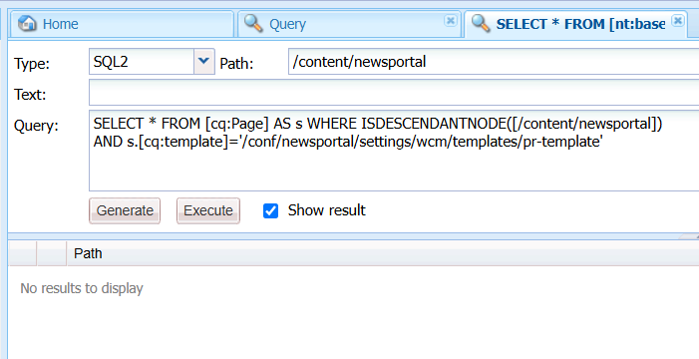

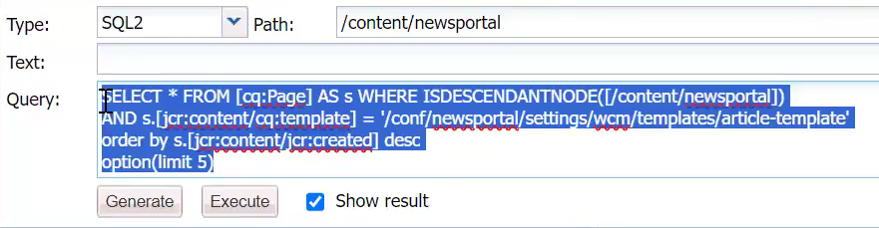

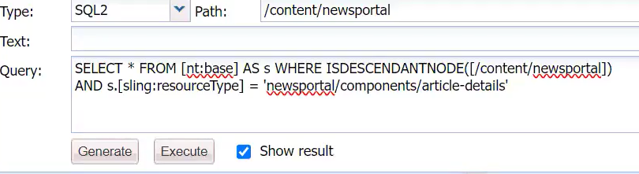

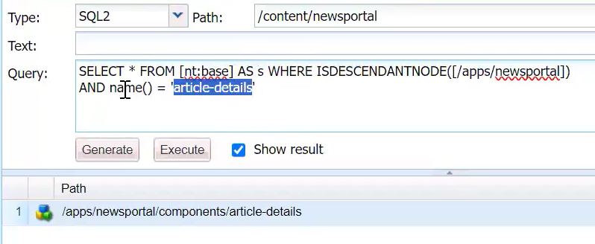

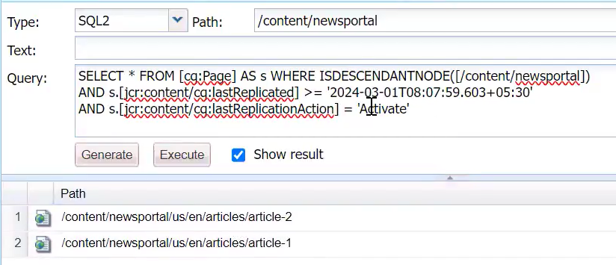

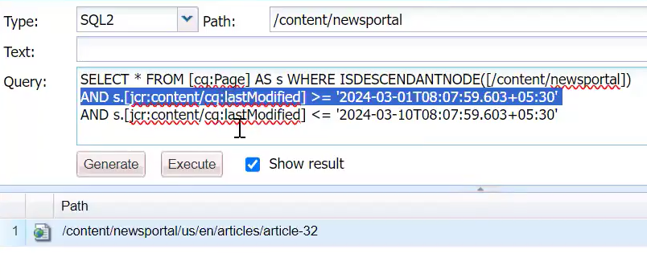

**RTE ( Rich Text Editor):**

Various mode of Editing:

* Inline editor
* Dialog editor
* Full Screen editor

<https://experienceleague.adobe.com/en/docs/experience-manager-65/content/sites/administering/operations/rich-text-editor>

<https://experienceleague.adobe.com/en/docs/experience-manager-65/content/sites/administering/operations/configure-rich-text-editor-plug-ins#textstyles>

There are 2 things are MANDATORY:

1. Need to cross check whether the plugins are enabled under rtePlugins node section
2. These plugins are enable in dialogFullScreen under uiSettings.

